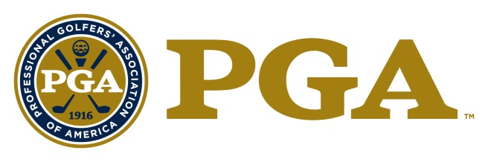

2020 PGA SPECIAL AWARDS PROGRAM
PGA Golf Professional of the Year

Description:
The "PGA Golf Professional of the Year Award" bestows special recognition on a PGA Golf Professional who has performed outstanding services as an overall PGA Professional. As one of the highest honors The PGA can bestow, candidates must possess outstanding qualities of leadership, strong moral character, and a substantial record of service to the Association and the game of golf. Individuals honored with the PGA Golf Professional of the Year award will be held as a model PGA Golf Professional.

Requirements:
- Candidate must be a PGA member in good standing.
- Candidate must be well regarded as a model PGA member.
- Demonstration and acknowledgement as an individual of outstanding leadership and strong moral character.

Eligibility:
- The following persons are ineligible:
- Previous National PGA Golf Professional of the Year award winners;
- Past Presidents of the Association;
- Current members of the Association Board of Directors;
- Nominees for National Office;
- Class "F" or "Inactive" members;
- Associates;
- PGA National Headquarters Staff and PGA Section Staff are not eligible for National Awards (Excluding Employees of PGA Golf Properties or Section Golf Properties).

Criteria:
PGA Golf Professional of the Year minimum criteria:
- Candidate must have been a Class A PGA member in good standing for a minimum total of 10 years.
- Candidate has developed the image, reputation, and ability to inspire fellow PGA members as a PGA Professional.
- Candidate must have maintained a substantial record of service to the Association and game of Golf, as well as helping to further educate and train their fellow PGA professionals.
- Candidate must have maintained a substantial record of service and promotion toward the Growth of the Game of Golf.

Guidelines for Selection:
The candidate will be considered on the basis of the following:
- The entire PGA career that will include all of their work as a PGA Professional including teaching and coaching experience, mentoring, education and training, player development, as well as service and commitment to the Game of Golf, their Association, and their Section;
- The overall performance as a PGA Professional;
- The impact made on the fellow PGA Professionals in the effort to lead and inspire them through contributions made to the Association and game of golf;
- The overall image as a PGA Professional and how the individual reflects the values of the PGA of America and the game of golf;
- The overall service to the Association in the effort to assist the PGA of America in its effort to meet its mission to promote the enjoyment of the game of golf, enhance the skills of PGA Professionals, elevate the standards of the professional golfers’ vocation, and promote the overall vitality of the game.

Other Considerations:
The National Award will be presented at the PGA Awards Ceremony, held in conjunction with the PGA Annual Meeting.

PGA GOLF PROFESSIONAL OF THE YEAR
NOMINATION

Name of Nominee: ______________________________________
Member Number: ______________________________________
Facility Name: ______________________________________
Facility Address: ______________________________________
Facility City, State, Zip: ______________________________________
Facility Phone Number: ______________________________________
Nominee E-mail Address: ______________________________________
Section Affiliation: ______________________________________

Nomination submitted by: ______________________________________

The nomination form should be typewritten.

- Please describe the nominee’s overall performance as a Golf Professional.

- Please briefly describe the nominee’s service to the local Section and to the Association.

- Please briefly describe the nominee’s leadership ability.

- Please briefly describe how the nominee inspires fellow Golf Professionals.

- Please briefly describe how the nominee grows the game of golf at the facility, in the community and throughout the Section.

- Please list any Section or National awards the nominee has received

Award | Year Received | Section

By submitting this form, the Executive Director and/or the Section attests that the information contained herein is accurate and truthful to the best of their knowledge, and that the nominee has been informed of, and has consented to, this Section Nomination.

Nomination Deadline: February 21, 2020

Nomination forms must be submitted through OpenWater, by the Section, using the email sent to the Executive Directors from OpenWater with account login information.

Should you have any questions, please feel free to contact:

Tricia Lovejoy
Senior Administrative Assistant
tlovejoy@pgahq.com
(561) 624-8590

Jenna Crowley
OpenWater Contact
jcrowley@pgahq.com

Tom Brawley
Senior Director, Membership Services
tbrawley@pgahq.com
(561) 624-8550

Incomplete and/or Ineligible Nomination Forms will NOT Be Considered.

Nominees who have been awarded the National Golf Professional of the Year are
NOT eligible

Books, videos and publications should NOT be submitted, but may be referenced in the
nomination form.

