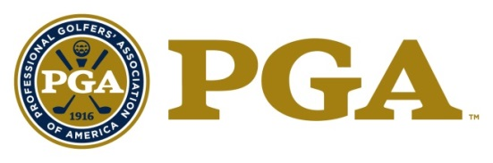

THE DEACON PALMER AWARD
2020 Nomination Form

Description:
The "Deacon Palmer Award" bestows special recognition on a PGA Golf Professional who personally displays outstanding integrity, character and leadership, in the effort to overcome a major obstacle in their life. This individual is an unsung hero/heroine at their facility and in their community, who serves to inspire, empower and assist others, both inside and outside of the game.

Requirements:
- Candidate must be a PGA member in good standing.
- Candidate must be well regarded as a model PGA member.
- Demonstration and acknowledgement as an individual of outstanding leadership and strong moral character.

Eligibility:
- The following persons are ineligible:
- Previous National PGA Golf Professional of the Year award winners;
- Past Presidents of the Association;
- Current members of the Association Board of Directors;
- Nominees for National Office;
- Class "F" or "Inactive" members;
- Associates;
- PGA National Headquarters Staff and PGA Section Staff are not eligible for National Awards (Excluding Employees of PGA Golf Properties or Section Golf Properties).

Criteria:
Deacon Palmer Award minimum criteria:
- Candidate must have been a Class ‘A’ PGA member in good standing and/or Associate for a minimum total of 10 years combined.
- Candidate must be well regarded as a model PGA member, demonstrating outstanding leadership traits and strong moral character.
- Candidate has developed the image, reputation, and ability to inspire, empower, and encourage success and achievement in individuals regardless of obstacles, disabilities, and personal challenges or otherwise.
- Candidate must have maintained a substantial record of service to the PGA of America, fellow PGA Professionals, their facility and the community in the effort to enhance and improve the quality of life for all individuals.
- Candidate must have maintained a continual record of service and promotion of the game of golf and golf industry.

Guidelines for Selection:
The candidate will be considered on the following:
- Their performance and service to the Association, fellow PGA Members, and the community to include contributions to building and growing the image of the PGA Professional, the Association and the game of golf while dealing with their own personal difficulty;
- Their entire PGA career with the primary emphasis on the service and commitment for others and their success regardless of situation;
- The significant impacts made on others and ability to inspire and encourage success and achievement in individuals regardless of the personal challenges they face;
- The significant influence made on Golf Professionals, facilities, and employers in the effort to assist others and better the community;
- Overall integrity and recognition as a person of outstanding character by PGA Professionals and leaders within the community;
- Other contributions provided to The PGA.

Other Considerations:
- The National Award will be presented at the PGA Awards Ceremony, held in conjunction with the PGA Annual Meeting.

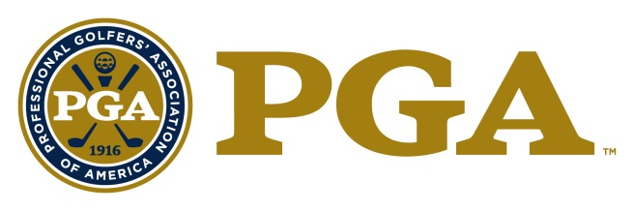

THE DEACON PALMER AWARD
NOMINATION

Name of Nominee: _________________________
Member Number: _________________________
Facility Name: _________________________
Facility Address: _________________________
Facility City, State, Zip: _________________________
Facility Phone Number: _________________________
Nominee Mobile Phone: _________________________
Nominee E-mail Address: __________________________
Section Affiliation: __________________________

The nomination form should be typewritten.

- Please describe the nominee’s service and commitment for others and their success regardless of situation.

- Please describe the nominee’s performance and service to the Association, fellow PGA Members, and the community to include contributions to building and growing the image of the PGA Professional, the Association and the game of golf while dealing with their own personal difficulty.

- Please describe the nominee’s significant impacts made on others and ability to inspire and encourage success and achievement in individuals regardless of the personal challenges they face.

- Please describe how the nominee has had significant influence on Golf Professionals, facilities, and employers in the effort to assist others and better the community.

- Please provide any additional information regarding the nominee and his/her contributions relevant to The Deacon Palmer Award.

- Please list any Section or National awards the nominee has received.

Award | Year Received | Section

By submitting this form, the Executive Director and/or the Section attests that the information contained herein is accurate and truthful to the best of their knowledge, and that the nominee has been informed of, and has consented to, this Section Nomination.

Nomination Deadline: February 21, 2020

Nomination forms must be submitted through OpenWater, by the Section, using the email sent to the Executive Directors from OpenWater with account login information.

Should you have any questions, please feel free to contact:

Tricia Lovejoy
Senior Administrative Assistant
tlovejoy@pgahq.com
(561) 624-8590

Jenna Crowley
Open Water Contact
jcrowley@pgahq.com
(315) 569-6943

Tom Brawley
Senior Director, Membership Services
tbrawley@pgahq.com
(561) 624-8550

Incomplete and/or Ineligible Nomination Forms will NOT Be Considered.

